Lab Work # 2 for 252 (2 Marks)

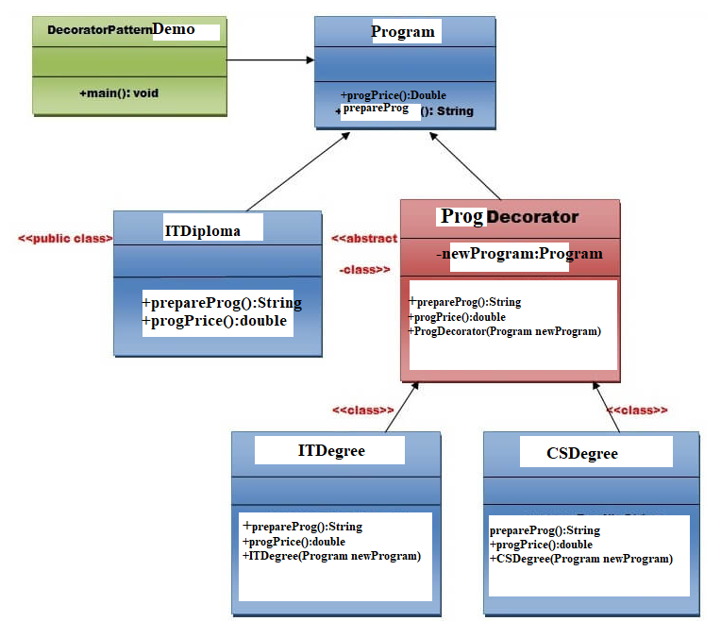

Extend the Decorator Factory pattern to implement the IS Degree. Draw class diagram including IS Degree and write the code. The deadline to submit is 31/10/24.

